mask = (df['total_sqft'].str.len() > 7)

df = df.loc[mask]

df

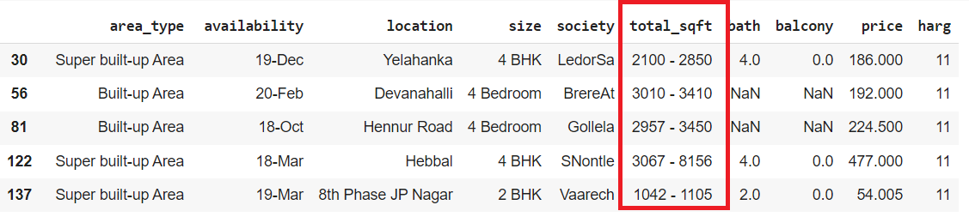

Comvierta total_sqft 2100 – 2200 a 2150 (promedio)

def ToNumber(x):

    tokens = x.split('-')

    if len(tokens) == 2:

        return (float(tokens[0])+float(tokens[1]))/2

    try:

        return float(x)

    except:

        return None

df.total_sqft = df.total_sqft.apply(ToNumber)